Iako svoju povijest započinje davne 1887.godine, današnja Trgovačko-ugostiteljska škola Karlovac osnovana je 1991. godine.

Na današnju lokaciju u Radićevoj 8 i 10 preselila je 1998.godine, gdje uz školske zgrade ima i svoje praktikume:

- Restoran *Pod starimi krovovi*

- Trgovine *Štacun pri Gambonu* i *Sladopekarna*

Svake godine škola obrazuje između 400 i 450 učenika u 6 programa/zanimanja:

- Komercijalist

- Prodavač

- Turističko-hotelijerski komercijalist

- Konobar

- Kuhar

- Slastičar

Kako bi se pripremili za buduća zanimanja, ali i život u EU, učenici uče četiri strana jezika: engleski, njemački, talijanski i francuski.

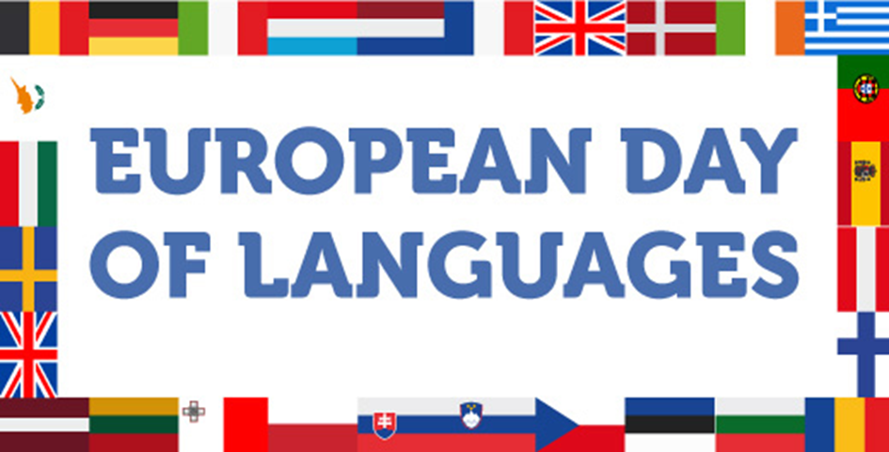

Although its history began back in 1887, today's Trade and Catering School Karlovac was founded in 1991. It has relocated to its present address, Radićeva 8 and 10, in 1998, where, along with school buildings, the school has its practical facilities:

* Restaurant (*Under old roofs*)
* Pastry shop (*Sladopekarna*)
* Shop (*Gambon's)*

Every year the school is attended by over 400 students in six vocational programs:

* Commercialist
* Shop assistant
* Commercialist in hotel and tourism industry
* Waiter
* Cook
* Pastry cook

To prepare for their future jobs, as well as life in the EU, students learn four foreign languages: English, German, Italian and French.

**LA GIORNATA EUROPEA DELLE LINGUE**

La scuola media superiore di commercio, ristorazione e industria albeghiera di Karlovac è stata fondata nel 1991.

Oggi si trova all’indirizzo via Radićeva 8-10, a Karlovac.

La nostra scuola è frequentata da circa 400 studenti.

I programmi di istruzione :

Commercialista turistico- alberghiero

Cameriere

Cuoco

Pasticciere

Commercialista

Commesso

Nella nostra scuola si studiano ben 4 lingue straniere : l’inglese, il tedesco, l’italiano e il francese.

**Journée européenne des langues**

École de Commerce et de Restauration

Notre école a été fondée en 1991. L’adresse de l’école est 8 et 10, rue Radićeva. Environ 400 élèves vont à l’école. Les programmes sont:

1) Commercial

2) Vendeur

3) Commercial du Tourisme et de l’Hôtellerie

4) Serveur

5) Cuisinier

6) Pâtissier

Aussi, on peut apprendre des langues étrangères. Ce sont l’anglais, l’allemand, l’italien et le français.

**Europäischer Tag der Sprache**

Wir sind die Schüler der Schule für Handel und Gastgewerbe in Karlovac.

Unsere Schule existiert seit dem Jahre 1991.

Sie liegt im Stadtzentrum , in der Radić-Straße 8-10.

Etwa 400 Schüler besuchen unsere Schule.

Sie lernen für:

• Kellner

• Köche

• Konditoren

• Hotelfachmann/frau

• Bürokaufmann/frau

• Verkäufer

Wir lernen viele Fremdsprachen: Englisch, Deutsch, Italienisch, Französisch.

In unserer Schule werden viele Wettbewerbe organisiert und durchgeführt.

Z.B.

• Das Wettbewerb in Fremdsprachen

• ,, Gastro“

• Junior Barmen Cup

Wir gehen gern zur Schule!